Lab Exercise 2 (WIE3007)

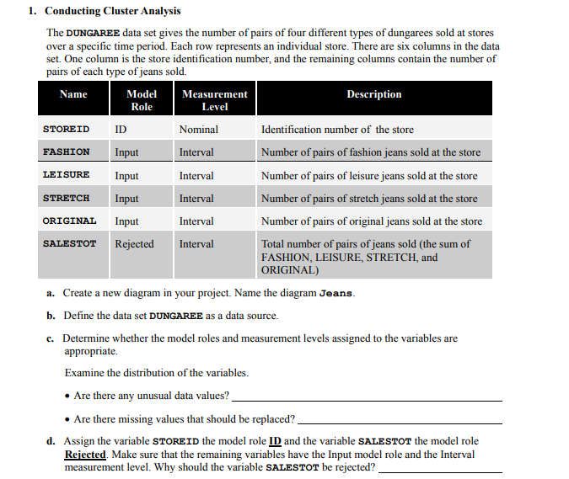



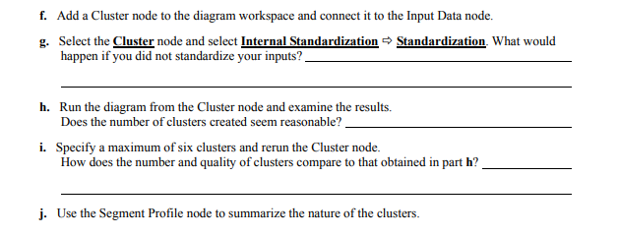

Answer:

1. Create new diagram name Jeans.

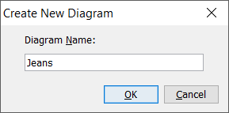

1. Data set Dungaree as data source.

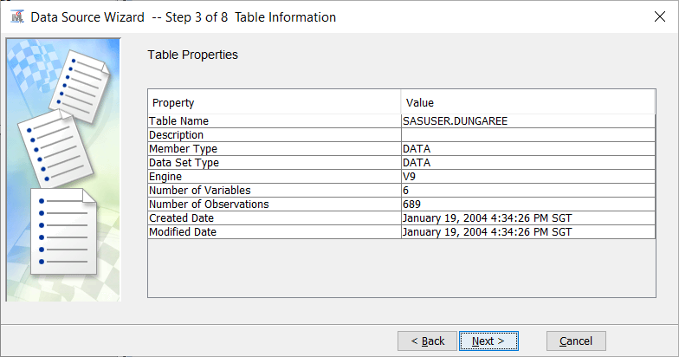

1. Select the following variable of interest and click **Explore**.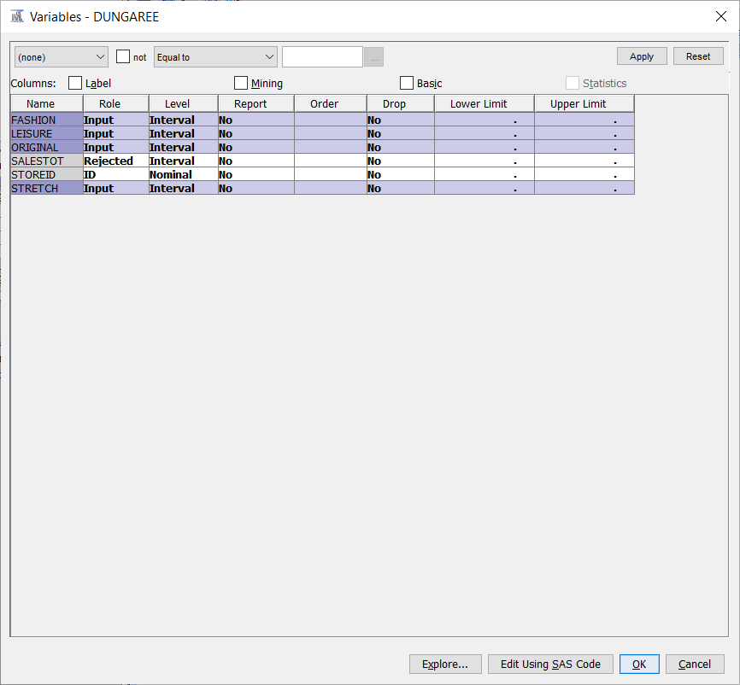

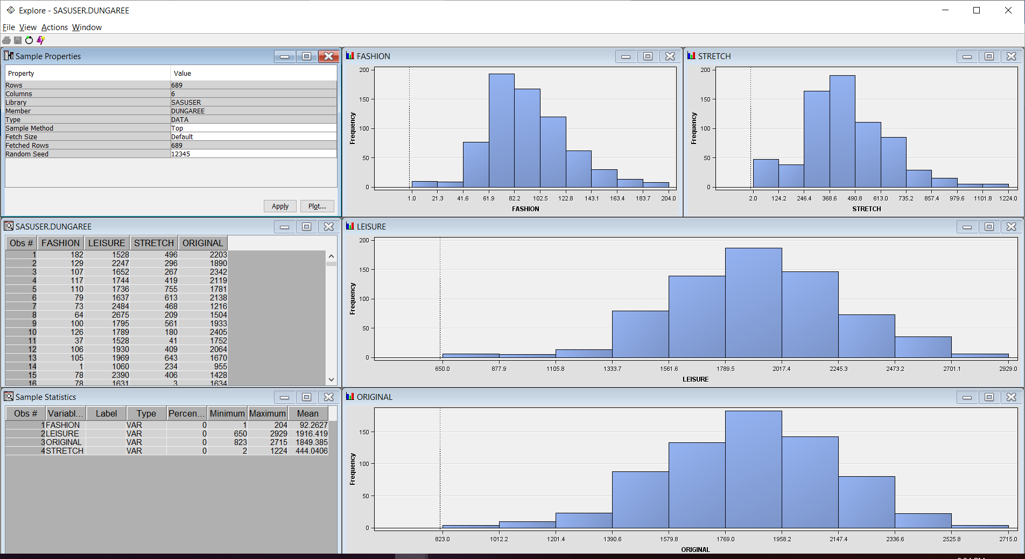

There is no any unusual or missing data value.

1. Assigned the **STOREID** with **ID** model role and **SALESTOT** with the **Rejected** model role.

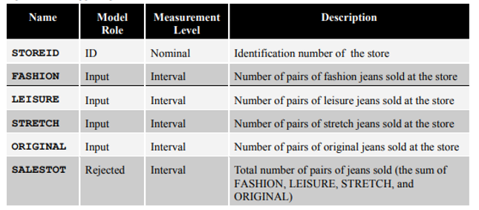

**SALESTOT** should be rejected because as mention in table above it is the sum of other variable in data set.

1. Add the **Dungaree** data source to the diagram.

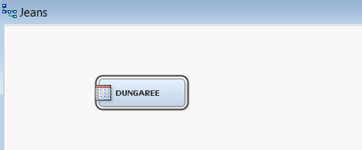

1. Added **Cluster** in diagram and connect it to the **Dungaree**.

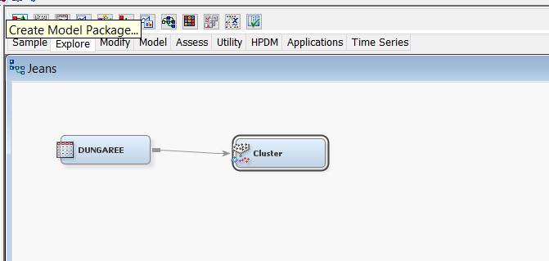

1. Select **Standardization for Internal Standardization**.

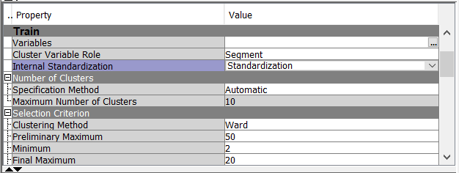

If do not standardize it, the cluster will occur strictly on the input with largest range.

1. Click run and display the result.

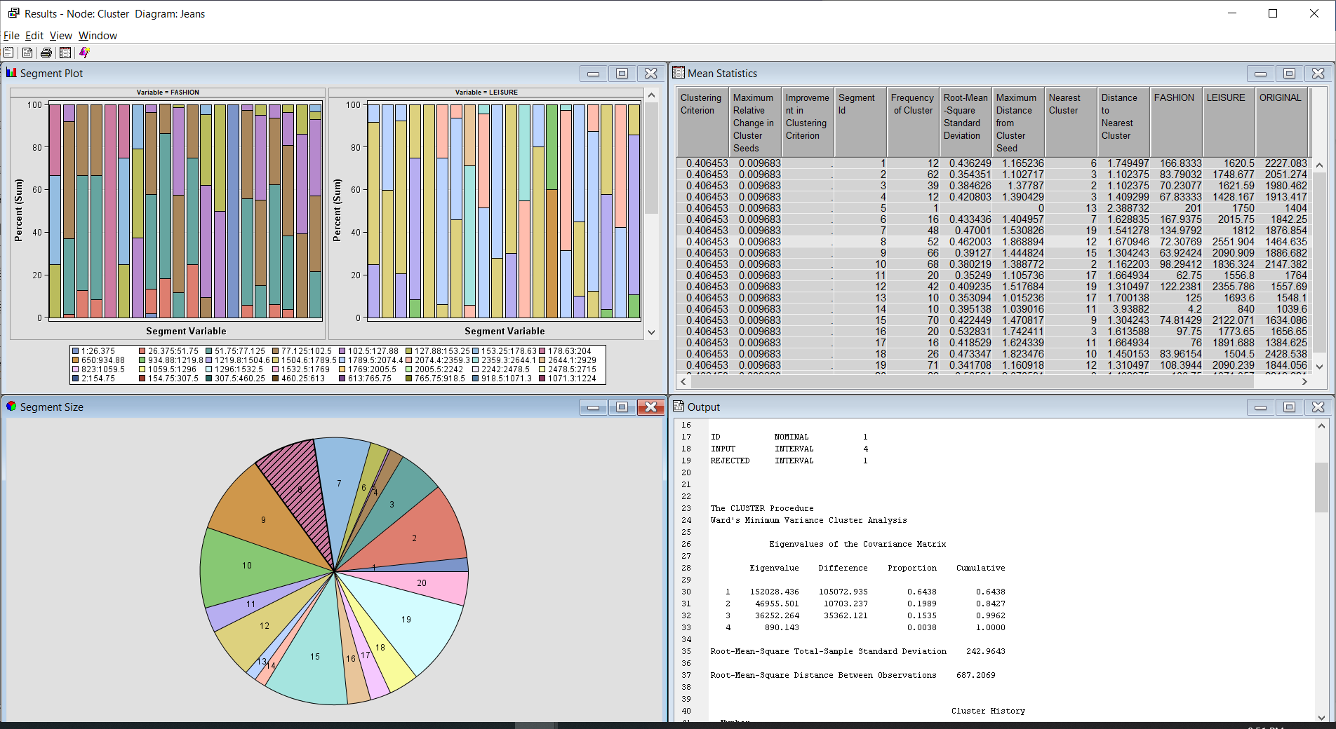

No, the cluster node automatic number of cluster seems to generate an excessive number of cluster as shown in the above result.

1. Change **Specification Method** to **User Specify** and **Maximum Number of Clusters** to **6**.

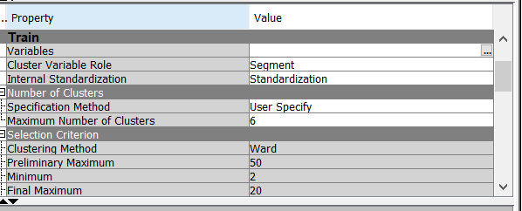

Click on run and view the result.

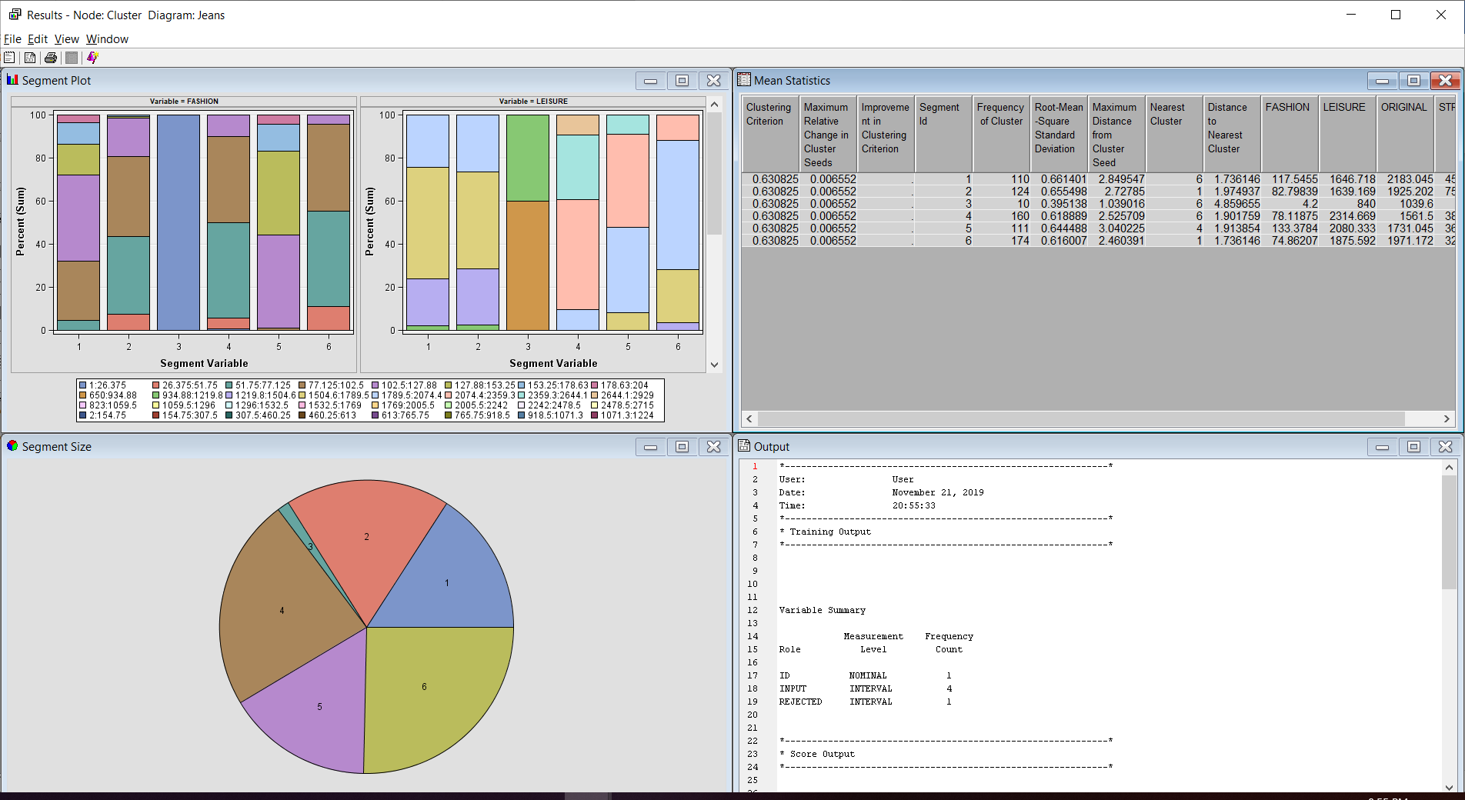

As compared to h, the segment of the result is well populated and look less compact.

1. Add the **Segment Profile** to diagram.

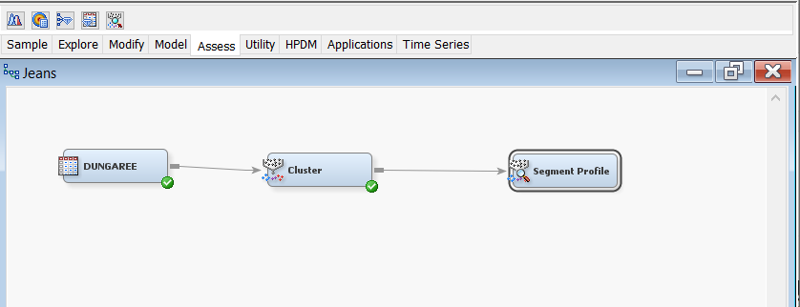

Click run and view the result.

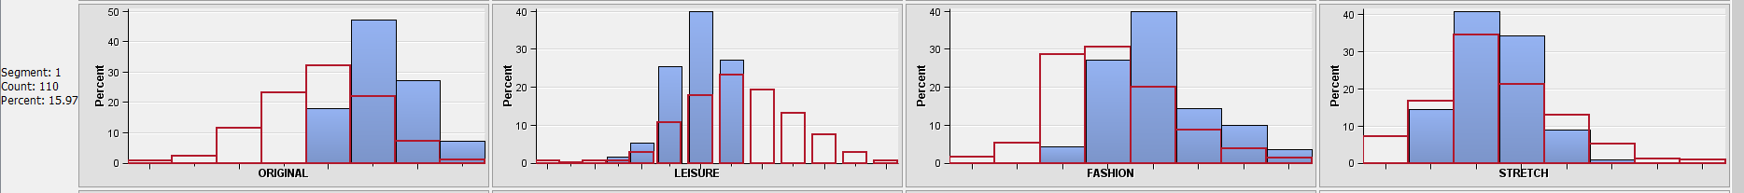

Segment 1 the result show higher than average in the sales number of Original jeans

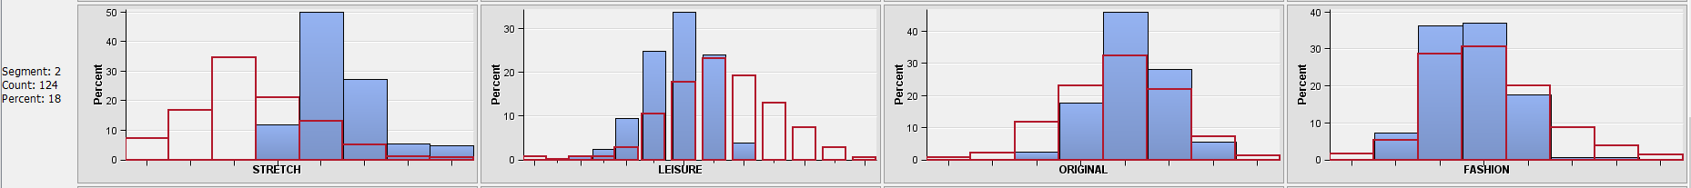

Segment 2 the result show higher than average in the sales number of stretch jeans

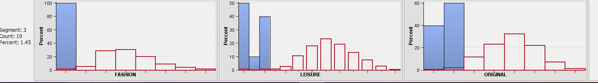

Segment 3 the result show less or smaller in the sales number of all jeans above

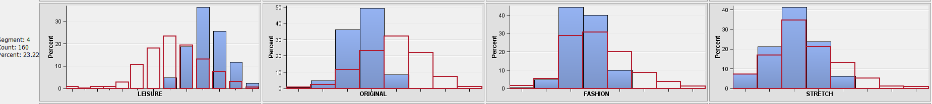

Segment 4 the result show higher than average in the sales number of leisure jeans

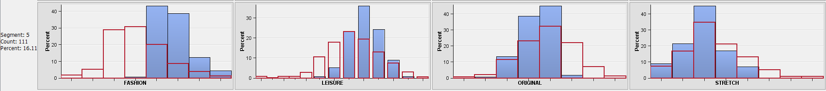

Segment 5 the result show higher than average in the sales number of fashion jeans

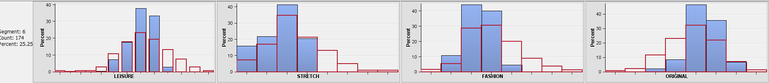

Segment 6 the result show higher than average in the sales number of original jeans